**Create a IBM Watson IOT platform and device**

|  |  |
| --- | --- |
| Team ID | PNT2022TMID24244 |
| Project Name | Smart waste management system for metropolitan cities |

[k](http://cbs.wondershare.com/go.php?pid=5239&m=db)

Remove Watermar



Wondershar

[e](http://cbs.wondershare.com/go.php?pid=5239&m=db)

PDFelemen

[t](http://cbs.wondershare.com/go.php?pid=5239&m=db)

Step 1: login into IBM CLOUD account

Step2: click on catalog and search for IOT platform

Step 3: Then search for IOT Watson platform then click on create

Step 4: Then click on add device and give the device type and necessary details then click finish

Step 5: Finally, IOT Watson platform is successfully created

**Screenshots of IBM Watson IOT platform and device:**

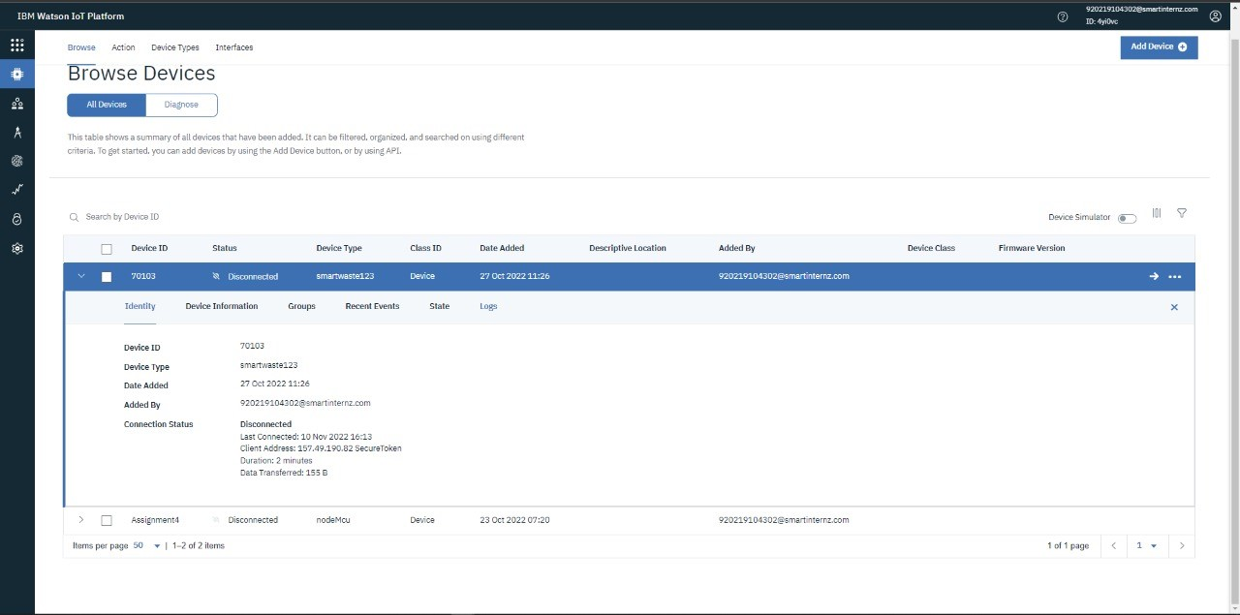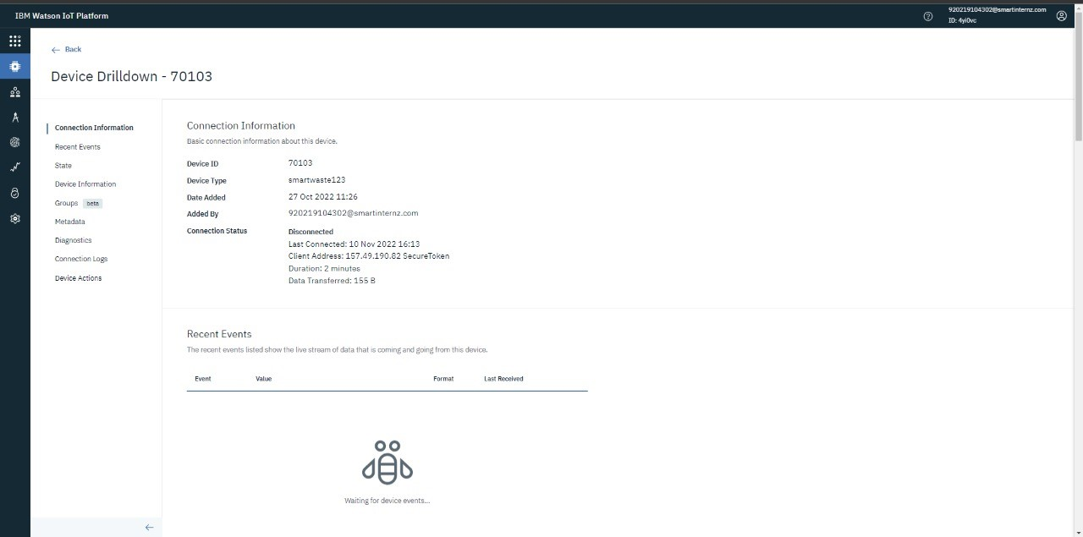

[k](http://cbs.wondershare.com/go.php?pid=5239&m=db)

Remove Watermar



Wondersh

~~ar~~

[~~e~~](http://cbs.wondershare.com/go.php?pid=5239&m=db)

PDFelemen

[t](http://cbs.wondershare.com/go.php?pid=5239&m=db)